Reduction, proliferation and differentiation defects of stem cells over time - a consequence of selective accumulation of old centrioles in the stem cells?

Jaba Tkemaladze*
Free University of Tbilisi. 240 David Aghmashenebeli Alley, 0159, Tbilisi, Georgia
jtkemaladze@longevity.ge

Abstract

All molecules, structures, cells in organisms are subjected to destruction during the process of vital activities. In the organisms of most multicellular animals and humans, the regeneration process always takes place: destruction of old cells and their replacement with the new. The replacement of cells happens even if the cells are in perfect condition. The sooner the organism destroys the cells that emerged a certain time ago and replaces them with the new (i.e. the higher is the regeneration tempo), the younger the organism is.

Stem cells are progenitor cells of the substituting young cells. Asymmetric division of a mother stem cell gives rise to one, analogous to the mother, daughter cell, and to a second daughter cell that takes the path of further differentiation. Despite such asymmetric divisions the pool of stem cells diminishes in its quantity over time. Moreover, intervals between stem cell divisions increase. The combination of these two processes causes the decline of regeneration tempo and aging of the organism.

During asymmetric stem cell divisions daughter cells, with preserved potency of the stem cell, selectively conserve mother (old) centrioles. In contrast with molecules of nuclear DNA, reparations do not take place in centrioles. Hypothetically, old centrioles are more subjected to destruction than other structures of a cell - which makes centrioles potentially the main structure of aging.

Keywords: centriole; differentiation; regeneration; aging; senescence; stem cells

1. Introduction
Development of a complex multicellular organism requires precise coordination of a growth, cell division, cell differentiation and cell death. All these processes must be under elaborate and coordinated control for they must be integrated into all cells and tissues. All >3,72 * 10 ¹³(Bianconi, 2013) cells of a fully grown human stem from a single cell - fertilized egg (Vaillancourt, 2009). Among tens of trillions of cells there are under 200 types of them (Khan, 2022). This implies that the development of an organism is accompanied by 2 processes in the least: firstly, by extremely intensive cell proliferation that requires many trillions of mitoses; secondly, by emergence of differentiation among cells with an increase of cell amount (Boulan, 2021).
There is a constant replacement of old cells with the new - regeneration process goes on unceasingly. In theory, regeneration tempo should remain steady as stem cells - source of cell and tissue regeneration - must not decrease in quantity. The stem cells divide asymmetrically: as mother stem cell divides, one of its daughter cells takes the path of differentiation. While the other daughter cell preserves a potency of a stem cell, thus remaining identical to the mother stem cell. Thus, the ‘depleted’ mother stem cell is replaced by the daughter cell with preserved stemness potency - the stem cells quantity is kept intact, accordingly. On that basis, organisms of animals and humans must not age. But prevailing conditions are reversed, one generation of people after another ages and so far not a single mutation has taken place that might turn things around and put a halt to aging. Our current understanding of stem cells, their potency and cell differentiation are still insufficient to understand the aging mechanisms.
1.1. Potency and differentiation
The word ‘potency’ usually defines the ability or capacity, however not necessarily realized; in its reference to a cell, the term ‘cellular potency’ is usually exercised to determine to what extent the given cell is able to become an ancestral cell to cells of various kinds (irrespective of their amount) (Binder, 2009). As a fertilized egg serves as an ancestral cell to all the cell types in the organism, it is called totipotent cell (Hansis, 2006). For how many generations is totipotency preserved in progeny cells? Ordinarily when a fertilized egg (zygote) divides as a result of first mitosis it leads to the formation of the daughter cells of embryo, later daughter cells unanimously take part in further development of an embryo. However sometimes these cells of a 2-cell embryo separate, each forming a complete organism, and as they share identical sets of genes, their individuals develop exactly alike, thus developing into monozygotic twins (MZ) (Silva, 2011). Thus it proves that after the first (and possibly after second and even third) division both daughter cells maintain totipotency (Galan, 2013). Interestingly, MZ twinning is closely associated with a stable DNA methylation signature in adult somatic tissues. This signature spans regions near telomeres and centromeres, Polycomb-repressed regions and heterochromatin, genes involved in cell-adhesion, WNT signaling and cell fate.

1.2 Differentiation and modulation
There are many somatic cells similar to further differentiated cells of other types. When these cells find themselves in different mediums, without division (an indispensable condition for differentiation) they revert back to the early stage of differentiation. As they start to proliferate they are able, for instance, to regenerate a lost limb with the help of wearable bioreactor (Murugan, 2022). Manifestation of their former potencies most probably indicate that they have not lost referred potencies - simply the cells took a certain shape different from the one they had had before being subjected to the seeming differentiation (Driesen, 2014). In cases when a cell becomes visually “differentiated” maintaining its characteristic potencies then it is referred that such a cell was exposed to modulation (Ham, 1987).

1.3. Cells’ classifications according to the level of differentiation (morphogenetic status).
In a developing embryo the differentiation usually takes place gradually and it is related to formation of various cell lines (Shankar, 2021). Due to the gradualness of differentiation in generations, cells of embryo/adult organisms may be of different lines and different generations - namely to be at various levels of differentiation with different morphogenetic status (Tkemaladze J., 2022). Thereupon the cells have various potencies (Han, 2020). From a point of morphogenetic status, they can be classified into following categories:

- Totipotent cells of the first 2 (possibly more) divisions of a zygote.
- Cells of intermediate generations, between the progenies of morula cells until their last generation, are pluripotent/ multipotent/bipotent. These cells have the potency to be progenitor cells of two/more than two cell types (Sobhani, 2017). In the process of a differentiation-inducing division these cell types give rise to two daughter cells different from each other and from their progenitor cell (Gönczy, 2005). Differentiation-inducing division in the niche of stem cells (Venkei, 2018) - one of the daughter cells is no different from the mother cell (Chen, 2016) - is an individual case of the concerned category.
- The end cells of the last generations are the end result of the differentiation, they possess no potency (Giehl, 2007).
- Sex cells of humans and animals. Despite their radical differences from somatic cells, specification of germ line in the course of embryogenesis is conceptually the same as the specification of any type of somatic cells: germ cells must activate a particular gene regulatory network to differentiate and pass through gametogenesis (Ewen-Campen, 2010).

1.4 Differentiation and proliferation rate decreases with aging alongside with the reduction of stem cells
In a fully-developed organism of multicellular animals regeneration takes place - replacement of old somatic cells with the new. Different cell types have different regeneration periods (Spalding, 2005). Even cells that were earlier considered to be unrestorable are subjected to replacement - neurons (Boldrini, 2018) If the regeneration process is constantly active and does not diminish, in theory the organism must not age - affected/mutated cells will be constantly substituted with healthy and new cells. But regeneration tempo declines with aging (Pechersky, 2016). Most probably it is due to the fact that stem cell quantity decreases with geometric sequence that accelerates aging (Encinas, 2012). Establishing the reason for reduction of stem cells can be, possibly, determined through in-depth examination of molecular mechanisms of differentiation of somatic cells and their impact on stem cells (Eckfeldt, 2005).

2. Creation and improvement of differentiation mechanisms’ concepts
Since the concept of gene was put forth at the end of XIX century the assumption of genetic mutations, elimination and deletions without exertion of lethal action was put forward. Such a mutant cell can continue division and pass on its alterations of DNA to its progenies. It was assumed that different cells lose different genes, therefore cells, belonging to different families, must possess different physical and functional characteristics (Weisann, 1890). After the development of methods of chromosomal analysis it turned out that the majority of animal cell types have the same chromosome set, and DNA composition in all somatic cells is also the same (Batty, 2019). It became necessary to find inducers that switch morphogenetic status of the mother cell to different morphogenetic statuses in daughter cells through divisions that cause differentiation.

2.1. There are no differentiation inducers in the nucleus of somatic cells
The differences of somatic cells with different morphogenetic statuses were supposed to be due to the fact that different genes were repressed in them, and also different genes were available for expression (Brown, 2003). The removal of the nucleus from the ovum and its replacement with the nucleus of a somatic cell that was subjected to certain differentiation (Campbell, 2001) has proved once more that (Briggs, 1960) there are no factors inducing differentiation in nuclei of somatic cells - fully developed clones are the best proof of it starting from 1960.

2.2. Differentiation inducers in cytoplasm of somatic cells
If nuclear transplantation from somatic cell into enucleated zygote takes place within the same species, i.e. nuclear donor cells and oocytes belong to the same species, this is called interspecies nuclear transplantation (Gurdon, 2011). If oocytes and nuclear donor cells are of different species, such nuclear transplantation is defined as cross-species nuclear transplantation (CSNT). (Moore, 1960). Since efficacy of somatic cell CSNT remains low, it points to a decisive point of cytoplasmic medium of oocyte. (Narbonne, 2012). Nevertheless, when it same to cloning of some endangered mammals, such as the gaur (Lanza, 2000), the mouflon (Loi, 2001), the African wild cat (Gómez, 2004), the sand cat (Gómez, 2008) and the coyote (Hwang, 2013), CSNT has proven to be of essence - the oocytes were obtained from their closely related species. Increased probability of CSNT between closely-related species and practically zero probability of CSNT between distantly related species indicate that the regulation system of differentiation and inducers themselves must be highly related, compatible.

Though cloning experiments eliminated the possibilities of finding differentiation inducers in nuclei of somatic cells, there is every likelihood that they are produced by nuclear DNA (RNA/protein) and taken beyond the nuclear membrane before the onset of differentiation. Unlike the chromosomes that are distributed between daughter cells evenly in the course of mitosis, the cytoplasm is not distributed to daughter cells equally either by its quantity, or quality(Wen, 2020). Therefore it is plausible to search for differentiation inducers in stable and self-replicating structures of cytoplasm - mitochondria and centrioles. (Chichinadze, 2008).

3. Are differentiation inducers associated with centrioles?
Early cell biologists considered centrosomes with couples of centrioles with stable cell structure immersed in them to be necessary for proliferation. (Schwarz, 2018). Now it is known that neither centrioles nor centrosomes are essential for cell proliferation. (Gadde, 2004). But it is unclear whether centrioles are essential for differentiation.

3.1. Centrioles in somatic cells

The canonical centriole is characterized by the ninefold symmetrical arrangement of microtubule triplets.
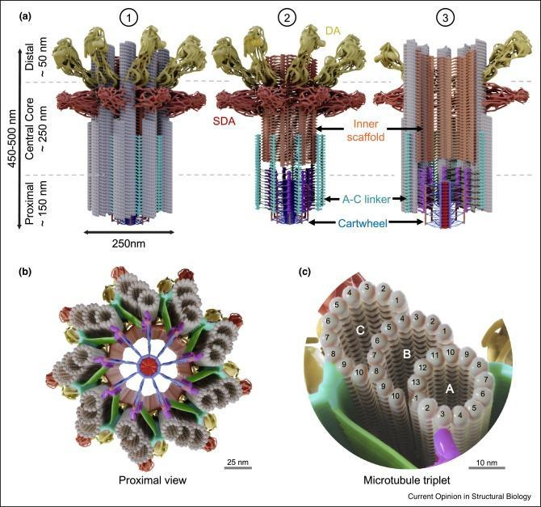
Figure 1. Model of the centriolar architecture.
(a) Model of the distinct structural regions of the centriole. (1) Complete view of the centriole, (2) Centriole view without microtubule blades highlighting non-microtubule structural features, (3) Longitudinal cross section highlighting luminal structural elements. (b) Centriole seen from the proximal side. (c) Zoomed view of microtubule triplet with labeled protofilaments. Cartwheel, blue; CID, red; D2 density, orange; pinhead, magenta; triplet base, green; A-C linker, cyan; inner scaffold, orange; subdistal appendage, dark red; distal appendages; yellow; tubulin, gray. (Le Guennec et al., 2021)

The proximal region of the centriole is composed by several substructures. One of the first identified was probably the cartwheel. The pinhead runs from the proximal end of the microtubule wall, and terminates at, or within a few nanometers from the end of the cartwheel. 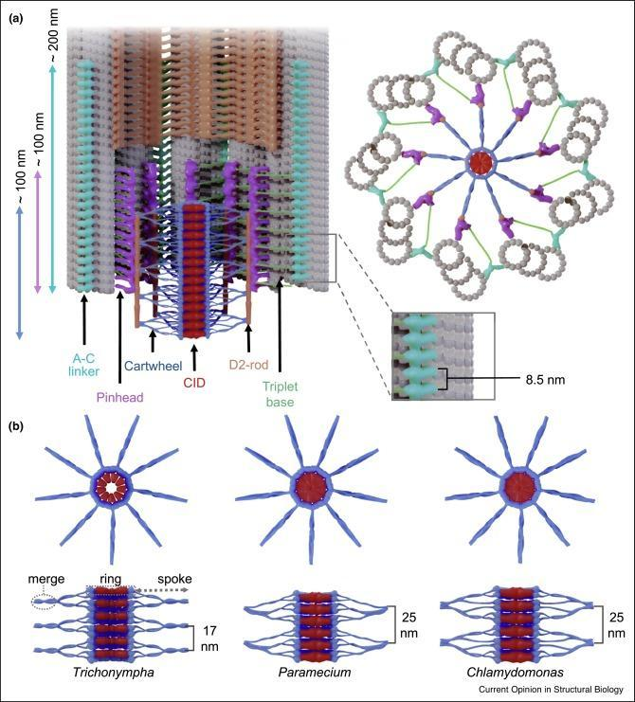
Figure 2. The proximal organization of the centriole.
(a) Longitudinal cross section (left) and top (right) views of the proximal part of the centriole. The inset (bottom right) highlights the periodicity observed for the A-C linker structure. (b)Transversal (top) and lateral (bottom) cross-sections of cartwheels from Trichonympha (left), Paramecium (middle), and Chlamydomonas (right). (Le Guennec et al., 2021)

Occupying the region immediately distal to the proximal region, and extending towards the distal end of the microtubule triplets, lies the inner scaffold.
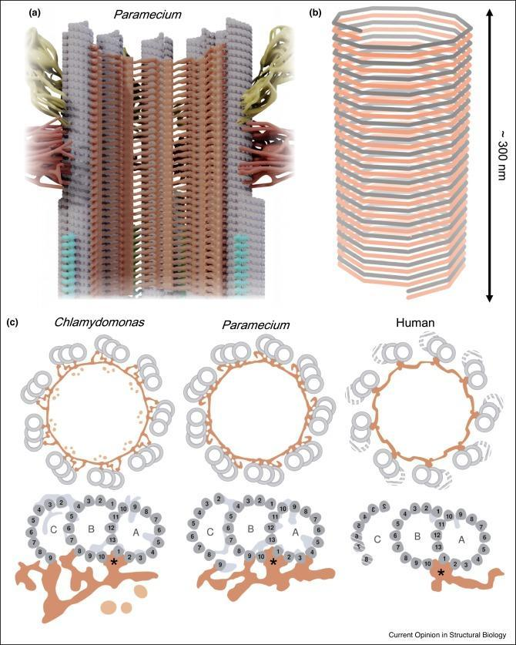
Figure 3. The central core and inner scaffold.
(a) Longitudinal cross section of the central core Paramecium centriole. (b) Graphical representation of the helical pattern of Paramecium inner scaffold. (c) Graphical representation of transversal cross sections of the central core of Chlamydomonas, Paramecium, and human centriole, with zoomed inset of inner scaffold connection with the microtubule triplets/doublets. The asterisks indicate the conserved position of the stem. (Le Guennec et al., 2021)

Despite the breakthrough in research of the structure of centriole, its role within the cell is still shrouded with mystery. Distribution of chromosomes between daughter cells, other functions during mitosis were attributed to centrioles - all the assumptions turned out to be wrong. Moreover, distortion of ratio of centriole number and chromosome number in transformed cells and tumor cells most likely indicates centriole as a structure involved in differentiation, but not as a regulator of mitosis (acentriolar somatic cells perfectly divide and perfectly distribute genetic material between daughter cells). Currently it is known that centrioles organize pericentriolar components in a discrete focus functioning as a biochemical center (Woodruff, 2014). The mechanism remains an enigma, but the effect is obvious in mouse blastocyst where centrioles do not emerge until second or third mitosis (Calarco-Gillam, 1983). Centrioles are inherited in successive cell cycles as preliminarily formed protein structures, very resistant to conditions that destroy other microtubules (Bobinnec, 1998).
Centrioles gather by the proximal end of preexisting centriole that was constituted at an earlier cell cycle and was passed down through mitosis and cell division. (Gönczy, 2019). The concept of a preliminary-formed matrix of microtubules or genome localized in centrioles that govern centrioles’ assembly was discarded due to the absence of experimental support. (Marshall, 2000). Nevertheless, an almost universal pattern indicates that a parent centriole contributes to a new centriole assembly in some way. In one of the first research, addressing the solution of this matter on cultivated cells, microsurgical methods were used to create cytoplasts (an enucleated cell) containing centrioles but devoid of nucleus and karyoplasts containing nucleus, however, devoid of centrioles. Karyoplast maintained its vitality, but new centrioles were not produced (Maniotis, 1991). If centrioles are not produced de novo (Nabais, 2021) this suggests that preexisting centrioles might be necessary for assembly of new centrioles. The consecutive research examined cell fragments under continuous microscopic monitoring and brought to three important results (Hinchcliffe, 2001). First, acentriolar karyoplasts entered mitosis and completed it, it proved in vitro studies correct that indicate that centrosomes are not essential for the formation of bipolar spindles (Wadsworth, 2004). Second, acentriolar cells’ execution of cytokinesis was less successful compared to the cells with centrioles thus pointing to the role centrioles play in accuracy of cytokinesis. Third, acentriolar cells, generated by cytokinesis, halt before the entry into S-phase, as though cells can not leave G1 without centrioles much the same as cells that can not leave mitosis without bipolar spindle.

3.2. Centriolar cytogenetic theory of differentiation and aging
If centrosomes/centrioles are not important for origination of microtubules, spindle assembly, then why are centrosomes and centrioles present in every differentiated somatic cell of animals? Presumably the pivotal function of this organoid of somatic cells of animals and humans is in its association with differentiation inducers (Tkemaladze, 2005). It was demonstrated that most types of somatic cells showcase stereotyped heredity of either mother, or daughter centrosomes thus bringing varying input to the fate of daughter cells after differentiation-inducing division (Chen, 2021). Centrosome reduction in oocytes holds a key role in prevention of parthenogenetic embryogenesis and balancing centrosome number in the embryonic cells (Manandhar, 2005). Destruction of centrioles in the generation process of haploid eggs from diploid somatic cells (Hartung, 1977) presumably is a point of reference for the restoration of totipotency - ‘null’ morphogenetic status. As sperm and oocyte undergo fusion, the resulting totipotent zygote divides and gives rise to its first generation - 2 totipotent cells. These cells also divide and produce the next generation of totipotent cells (Maemura, 2021), and thus it continues until the formation of de novo centrioles at a certain generation (Abumuslimov, 1994; Maro, 1991). Cells of that generation lose their totipotency from the moment of formation of centrioles (Ishiuchi, 2013) and turn to the path of irreversible differentiation - they acquire a certain morphogenetic status. Alteration of morphogenetic status signifies that one gene network has been turned off, while the other turned on (Roy, 2014). The number of cell generations, starting from zygote, is restricted by Hayflick limit (Hayflick, 1997).

On the basis of aforementioned the following assumptions can be put forth:

- Hypothetically it can be suggested that in between destruction of centrioles as in spermatogenesis (Simerly, 2001), so during oogenesis (Simerly, 2018), prior to formation of centrioles de novo (Zhou, 2015) two hypothetical structures of inducers are built on the basis of nuclear or mitochondrial DNA. Most probably these differing structures consist of protein or RNA, or the combination of the two. It is possible that one structure is associated with an old centriole, whereas the second structure is associated with a young centriole.
- Inducers connect from outside/inside with centrioles: one of two hypothetical structures (let us name it a structure inducing progenitor cells of somatic cells - S-structure) is linked with one centriole, whereas the second hypothetical structure (let us name it a structure inducing progenitor cells of haploid cells - H-structure ) is linked with a second centriole.
- In the course of centrioles’ duplication (Nigg, 2017) centriole with S-structure generates daughter centriole to which a copy of a H - structure from pair centriole with H-structure is attached. Whereas the pair centriole with H-structure generates daughter centriole with attached copy of S-structure from its former pair with S-structure. After the differentiation-inducing division (Seirin-Lee, 2020), in the process of centrioles reduplication the one-by-one release of corresponding inducer issues from a set of both mother centrioles. There is a detachment of corresponding differentiation inducer from S-structure in one daughter cell, and another corresponding differentiation inducer’s detachment from H-structure takes place in the second daughter cell. Switches of gene network take place, daughter cells acquire different morphogenetic statuses - different and higher than the morphogenetic status of the mother cell.
- There are less inducers after each differentiation-inducing division. Since during differentiation-inducing divisions the differentiation inducer detaches only from the mother centriole, but not from the daughter centriole, then in certain generations there is an emergence of cells that have different amounts of inducers in S- and H-structures’ sets. If the set of inducers in one of the structures (S-structure or H-structure) is completely depleted, while it is not depleted in the second structure, then such a cell becomes a multipotent stem cell capable of asymmetrical division (Chang, 2008). It is highly likely that morphological characteristic of a total depletion of one of inducer structures is the presence of primary cilium. One daughter cell will be identical to the mother cell as its inducers’ store is depleted at corresponding centriole (whereas there is inducers’ store in its daughter centriole). Thus, the stem cell pool contains old mother centrioles that do not reparate. Such irreparable centrioles must lose functionality and cause the death of stem cells wherein they are located.
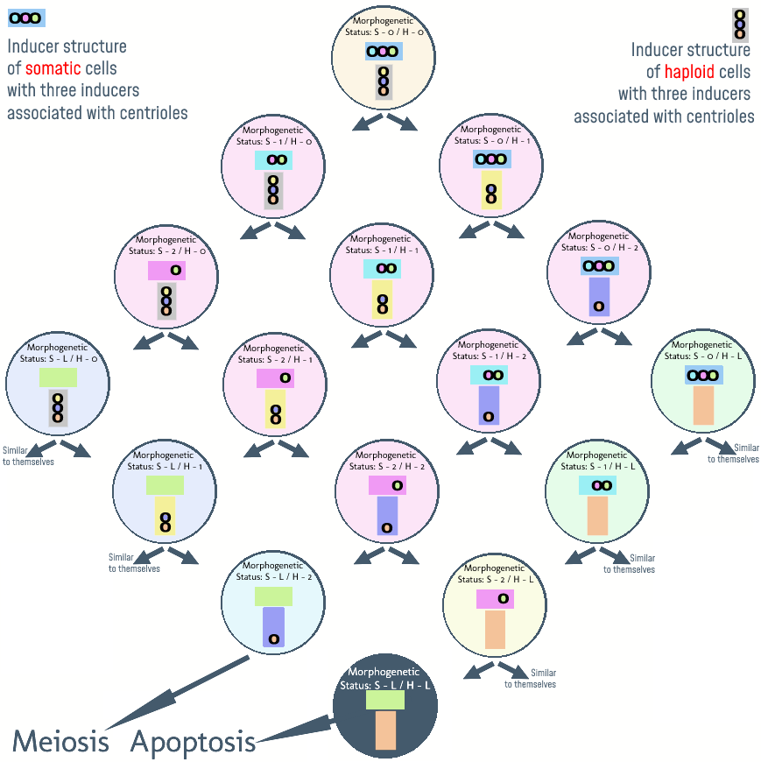
Figure 4. Variation pattern of morphogenetic status in lines of progeny cells when S-structure consists of 3 inducers, and H-structure consists of 3 inducers too.
S reflects affiliation to the inducers of somatic lines, H reflects affiliation to inducers to the lines of haploid gametes. Numbers show how many inducers have already separated from the inducer structure. Letter L signifies that the limit of a corresponding line has been reached - all the inducers of the corresponding line have been liberated. A totipotent cell with centrioles formed de novo and with null morphogenetic status, accordingly, S-0/H-0 is progenitor for pluripotent embryonic stem cells with S-1/H-0 and S-0/H-1. On this hypothetical diagram it is easy to notice that for a cell with a certain morphogenetic status, for instance, S-1/H-1’s progenitors can be cells with different morphogenetic status, in this particular case those are S-1/H-0 and also S-0/ H-1. As long as there is at least 1 inducer left in both inducer structures, the cell is a pluripotent embryonic stem cell. Multipotent mature stem cells are the result of depletion of one of the inducer structures and, in theory, they can yield progenie analogous to themselves limitlessly. They are also progenitors for unipotent cells with S-2/H-L and S-L/H-2. Cells with S-2/H-L are progenitors for highly-differentiated cells and whose progenies will reach Hayflick limit with preprogrammed apoptosis. Whereas S-L/H-2 are the progenitors for the future germ cells - the liberated last inducer triggers meiotic division. By the example of S-2/H-L and S-L/H-2 on this hypothetical diagram it is easy to see the significance of the medium to which an inducer liberates. Liberation of the last inducer of H-structure in the progeny line S-L/H-2 causes activation of meiotic division. Whereas the liberation of the same inducer in S-0/H-L causes the formation of a mature stem cell with the largest (for mature stem cell) potency. Thus, different gene networks switch the same inducers to different gene networks.

Reduction of the amount of stem cells over time becomes the reason for stem cells' rarer division. Accordingly, the amount of cells that are on the path of further differentiation, progenitors of highly-differentiated cells, is continually less. Therefore frequency of cell renewal in tissues takes longer time, regeneration tempo declines, organism ages.

4. Discussion
Reduction of regeneration potency of tissues is one of the most obvious aging characteristics (López-Otín, 2013). For instance, hematopoiesis decreases with aging; it leads to the reduction of production of adaptive immune cells (Shaw, 2010). Such functional loss of stem cells has been detected in practically every compartment of mature stem cells, including mouse forebrain (Molofsky, 2006), the bones and the muscle fibers (Conboy, 2012). Reduction of regenerative potency with aging has been predicted long ago, after experiments on transplantation of muscles obtained from an old organism to the young, and muscle transplantation from young organism to the old. These experiments have shown that (1) that chronological age alone is not a factor that limits the intrinsic ability of a muscle to regenerate and (2) that the poor regeneration of muscles in old animals is a function of the environment for regeneration provided by the old host (Carlson, 1989).

What if instead of whole muscle or organ transplantation we could transplant only stem cells? The experiment in question has already been carried out by Lavasani (Lavasani, 2012) and the result of it has been paradoxical: where only stem cells were transplanted, the result was the reverse effect of Carlson's experiments - transplant assimilated the host. Unfortunately, Lavasani transplanted only in one direction: stem cells of young organisms to the old.

Will a young organism age if it had stem cells transplanted to it from an old organism? The question remains to be answered. Until then and hopefully thereafter (if assimilation takes place as a result of transplantation of stem cells from old organism to the young) hypothesis about selective accumulation of old centrioles in stem cells is of essence. Due to the passing of time, more damaged old centrioles in stem cells make these stem cells less resistant to stress. Stem cell number decreases and so does the regeneration tempo. Quite possible that the damage to the stem cells’ old centrioles affects also differentiated daughter cells (old centriole serves as a matrix for daughter cells’ centrioles) that enables ripple-through effect on corresponding tissues accordingly.

Conclusion
Unfortunately, in his research Lavasini was unable to assess the significance of his finding. And he did not conduct the invert experiment that is a transplantation of stem cells from an old organism to a young organism. If young mice with transplanted stem cells from old mice start aging faster than individuals of the control group then the very centriole and its function must be immediately investigated. Instead of stem cells from old or young organisms, their centrioles must be subjected to transplantation.

Acknowledgements
To Leonard Hayflick for his patience and attention that he bestowed through analyzing and correcting this hypothesis. But most of all for his ingenious paper (Hayflick L., 2021). For the second time he has given hope for finding the main reason for aging.

References:
- Abumuslimov, SS., Nadezhdina, ES., Chentsov, IuS. 1994. [An electron microscopic study of centriole and centrosome morphogenesis in the early development of the mouse]. Tsitologiia.;36(11):1054-61. Russian.
- Batty, P., Gerlich, DW. 2019. Mitotic Chromosome Mechanics: How Cells Segregate Their Genome. Trends Cell Biol. doi.org/10.1016/j.tcb.2019.05.007
- Bianconi et al. 2013. An estimation of the number of cells in the human body. Ann Hum Biol. doi.org/10.3109/03014460.2013.807878
- Binder, MD., Hirokawa, N., Windhorst U. 2009. Cellular potency. (eds) Encyclopedia of Neuroscience. Springer, Berlin, Heidelberg. doi.org/10.1007/978-3-540-29678-2_875
- Bobinnec et al. 1998. Centriole disassembly in vivo and its effect on centrosome structure and function in vertebrate cells. J Cell Biol. doi.org/10.1083/jcb.143.6.1575
- Boldrini et al. 2018. Human Hippocampal Neurogenesis Persists throughout Aging. Cell Stem Cell. doi: 10.1016/j.stem.2018.03.015
- Boulan, L., Léopold, P. 2021. What determines organ size during development and regeneration? Development. doi.org/10.1242/dev.196063
- Briggs, R., King, TJ. 1952. Transplantation of Living Nuclei From Blastula Cells into Enucleated Frogs' Eggs. Proc Natl Acad Sci U S A. doi.org/10.1073/pnas.38.5.455
- Brown, G., Hughes, PJ., Michell, RH. 2003. Cell differentiation and proliferation--simultaneous but independent? Exp Cell Res. doi.org/10.1016/s0014-4827(03)00393-8
- Calarco-Gillam et al. 1983. Centrosome development in early mouse embryos as defined by an autoantibody against pericentriolar material. Cell. doi.org/10.1016/0092-8674(83)90094-6
- Campbel et al. Nuclear transfer in practice. 2001. Cloning Stem Cells. doi.org/10.1089/15362300152725927
- Carlson BM, Faulkner JA. 1989. Muscle transplantation between young and old rats: age of host determines recovery. Am J Physiol. doi: 10.1152/ajpcell.1989.256.6.C1262.
- Chang, JT., Reiner, SL. 2008. Asymmetric division and stem cell renewal without a permanent niche: lessons from lymphocytes. Cold Spring Harb Symp Quant Biol. doi.org/10.1101/sqb.2008.73.008
- Chen, C., Fingerhut, JM., Yamashita, YM. 2016. The ins(ide) and outs(ide) of asymmetric stem cell division. Curr Opin Cell Biol. doi: 10.1016/j.ceb.2016.06.001
- Chen, C., Yamashita, YM. 2021. Centrosome-centric view of asymmetric stem cell division. Open Biol. doi.org/10.1098/rsob.200314
- Chichinadze, KN., Tkemaladze, DV. 2008. [Centrosomal hypothesis of cellular aging and differentiation]. Adv Gerontol. 21(3):367-71. Russian.
- Conboy, IM., Rando, TA. 2012. Heterochronic parabiosis for the study of the effects of aging on stem cells and their niches. Cell Cycle. doi: 10.4161/cc.20437
- Driesen et al. 2014. Reversible and irreversible differentiation of cardiac fibroblasts. Cardiovasc Res. doi.org/10.1093/cvr/cvt338
- Eckfeldt, CE., Mendenhall, EM., Verfaillie, CM. 2005. The molecular repertoire of the 'almighty' stem cell. Nat Rev Mol Cell Biol. doi: 10.1038/nrm1713
- Encinas, JM., Sierra, A. 2012. Neural stem cell deforestation as the main force driving the age-related decline in adult hippocampal neurogenesis. Behav Brain Res. doi:10.1016/j.bbr.2011.10.010
- Ewen-Campen, B., Schwager, EE., Extavour, CG. 2010. The molecular machinery of germ line specification. Mol Reprod Dev. doi.org/10.1002/mrd.21091
- Gadde, S., Heald, R. (2004). Mechanisms and molecules of the mitotic spindle. Curr Biol. doi.org/10.1016/j.cub.2004.09.021
- Galan et al. 2013. Defining the genomic signature of totipotency and pluripotency during early human development. PLoS One. doi.org/10.1371/journal.pone.0062135
- Giehl, KM. 2007. Neuronal development. Prog Exp Tumor Res. doi.org/10.1159/000100041
- Gómez et al. 2004. Birth of African Wildcat cloned kittens born from domestic cats. Cloning Stem Cells. doi.org/10.1089/clo.2004.6.247
- Gómez et al. 2008. Nuclear transfer of sand cat cells into enucleated domestic cat oocytes is affected by cryopreservation of donor cells. Cloning Stem Cells. doi.org/10.1089/clo.2008.0021
- Gönczy, P., Hatzopoulos, GN. 2019. Centriole assembly at a glance. J Cell Sci. doi.org/10.1242/jcs.228833
- Gönczy, P., Rose, LS. 2005. Asymmetric cell division and axis formation in the embryo. WormBook. doi.org/10.1895/wormbook.1.30.1
- Gurdon, J.B. 1960. The developmental capacity of nuclei taken from differentiating endoderm cells of Xenopus laevis. J Embryol Exp Morphol. Dec;8:505-26.
- Gurdon, JB., Wilmut, I. 2011. Nuclear transfer to eggs and oocytes. Cold Spring Harb Perspect Biol. doi.org/10.1101/cshperspect.a002659
- Ham, Arthur W. (Arthur Worth), David H. Cormack. 1987. Ham’s Histology. 9th ed. Philadelphia: Lippincott. Print.
- Han et al. 2020. Construction of a human cell landscape at single-cell level. Nature. doi.org/10.1038/s41586-020-2157-4
- Hansis, C. 2006. Totipotency, cell differentiation and reprogramming in humans. Reprod Biomed Online. doi.org/10.1016/s1472-6483(10)60644-x
- Hartung, M., Stahl, A. 1977. Preleptotene chromosome condensation in mouse oogenesis. Cytogenet Cell Genet. doi.org/10.1159/000130777
- Hayflick, L. 1997. Mortality and immortality at the cellular level. A review. Biochemistry (Mosc). Nov;62(11):1180-90.
- Hayflick L. The greatest risk factor for the leading cause of death is ignored. Biogerontology. 2021. doi: 10.1007/s10522-020-09901-y
- Hinchcliffe et al. 2001. Requirement of a centrosomal activity for cell cycle progression through G1 into S phase. Science. doi.org/10.1126/science.1056866
- Hwang et al. 2013. Successful cloning of coyotes through interspecies somatic cell nuclear transfer using domestic dog oocytes. Reprod Fertil Dev. doi.org/10.1071/rd12256
- Ishiuchi, T., Torres-Padilla, ME. 2013. Towards an understanding of the regulatory mechanisms of totipotency. Curr Opin Genet Dev. doi.org/10.1016/j.gde.2013.06.006
- Khan, YS., Farhana, A. Histology, Cell. 2022. May 8. In: StatPearls [Internet]. Treasure Island (FL): StatPearls Publishing; 2022 Jan–. PMID: 32119269.
- Lanza et al. 2000. Cloning of an endangered species (Bos gaurus) using interspecies nuclear transfer. Cloning. doi.org/10.1089/152045500436104
- Lavasani et al. 2012. Muscle-derived stem/progenitor cell dysfunction limits healthspan and lifespan in a murine progeria model. Nat Commun. doi: 10.1038/ncomms1611
- Le Guennec et al. 2021. Overview of the centriole architecture. Curr Opin Struct Biol. 2021 Feb;66:58-65. doi: 10.1016/j.sbi.2020.09.015
- Loi et al. 2001. Genetic rescue of an endangered mammal by cross-species nuclear transfer using post-mortem somatic cells. Nat Biotechnol. doi.org/10.1038/nbt1001-962
- López-Otín et al. 2013. The Hallmarks of Aging. doi.org/10.1016/J.CELL.2013.05.039
- Maemura et al. 2021. Totipotency of mouse zygotes extends to single blastomeres of embryos at the four-cell stage. Sci Rep. dx.doi.org/10.1038%2Fs41598-021-90653-1
- Manandhar, G., Schatten, H., Sutovsky, P. 2005. Centrosome reduction during gametogenesis and its significance. Biol Reprod. doi.org/10.1095/biolreprod.104.031245
- Maniotis, A., Schliwa, M. 1991. Microsurgical removal of centrosomes blocks cell reproduction and centriole generation in BSC-1 cells. Cell. doi: 10.1016/0092-8674(91)90524-3
- Maro et al. 1991. Cell polarity and microtubule organisation during mouse early embryogenesis. Dev Suppl.;1:17-25.
- Marshall, WF., Rosenbaum, JL. 2000. Are there nucleic acids in the centrosome? Curr Top Dev Biol. doi.org/10.1016/s0070-2153(99)49009-x
- Molofsky et al. 2006. Increasing p16INK4a expression decreases forebrain progenitors and neurogenesis during ageing. Nature. doi: 10.1038/nature05091
- Moore, JA. 1960. Serial back-transfers of nuclei in experiments involving two species of frogs. Dev Biol. doi.org/10.1016/0012-1606(60)90053-1
- Murugan et al. 2022. Acute multidrug delivery via a wearable bioreactor facilitates long-term limb regeneration and functional recovery in adult Xenopus laevis. Sci Adv. doi.org/10.1126/sciadv.abj2164
- Nabais et al. 2021. Plk4 triggers autonomous de novo centriole biogenesis and maturation. J Cell Biol. doi: 10.1083/jcb.202008090
- Narbonne, P., Miyamoto, K., Gurdon, JB. 2012. Reprogramming and development in nuclear transfer embryos and in interspecific systems. Curr Opin Genet Dev. doi.org/10.1016/j.gde.2012.09.002
- Nigg, EA., Holland, AJ. 2018. Once and only once: mechanisms of centriole duplication and their deregulation in disease. Nat Rev Mol Cell Biol. doi.org/10.1038/nrm.2017.127
- Pechersky et al. 2016. Immune System and Regeneration. J Stem Cells. 2016;11(2):69-87. PMID: 28296866.
- Roy, S., Kundu, TK. 2014. Gene regulatory networks and epigenetic modifications in cell differentiation. IUBMB Life. doi: 10.1002/iub.1249
- Schwarz et al. 2018. Revisiting Centrioles in Nematodes-Historic Findings and Current Topics. Cells.doi.org/10.3390/cells7080101
- Seirin-Lee, S. 2020. Asymmetric cell division from a cell to cells: Shape, length, and location of polarity domain. Dev Growth Differ. dx.doi.org/10.1111%2Fdgd.12652
- Shankar et al. 2021. From Snapshots to Development: Identifying the Gaps in the Development of Stem Cell-based Embryo Models along the Embryonic Timeline. Adv Sci (Weinh). doi.org/10.1002/advs.202004250
- Shaw et al. 2010. Aging of the innate immune system. Curr Opin Immunol. doi:10.1016/j.coi.2010.05.003
- Silva et al. 2011. Why are monozygotic twins different? J Perinat Med. doi.org/10.1515/jpm.2010.140
- Simerly et al. 2016. Post-Testicular Sperm Maturation: Centriole Pairs, Found in Upper Epididymis, are Destroyed Prior to Sperm's Release at Ejaculation. Sci Rep. doi.org/10.1038/srep31816
- Simerly et al. 2018. Separation and Loss of Centrioles From Primordidal Germ Cells To Mature Oocytes In The Mouse. Sci Rep. doi.org/10.1038/s41598-018-31222-x
- Sobhani et al. 2017. Multipotent Stem Cell and Current Application. Acta Med Iran. Jan;55(1):6-23.
- Spalding et al. 2005. Retrospective birth dating of cells in humans. Cell. doi:10.1016/j.cell.2005.04.028
- Tkemaladze, J., 2022. Dasatinib and Quercetin: Short-term Simultaneous Administration Yields Senolytic Effect in Humans. Issues and Developments in Medicine and Medical Research Vol. 2, 22–31. doi.org/10.9734/bpi/idmmr/v2/15155D
- Tkemaladze, J., Chichinadze, K. 2005. Potential role of centrioles in determining the morphogenetic status of animal somatic cells. Cell Biol Int. doi.org/10.1016/j.cellbi.2005.03.003
- Vaillancourt, C., Lafond, J. 2009. Human embryogenesis: overview. Methods Mol Biol. doi.org/10.1007/978-1-60327-009-0_1
- Venkei, ZG., Yamashita, YM. 2018. Emerging mechanisms of asymmetric stem cell division. J Cell Biol. doi.org/10.1083/jcb.201807037
- Wadsworth, P., Khodjakov, A. 2004. E pluribus unum: towards a universal mechanism for spindle assembly. Trends Cell Biol. doi.org/10.1016/j.tcb.2004.07.004
- Weismann, A. 1890. Prof. Weismann's Theory of Heredity. Nature 41,317–323. doi:10.1038/041317g0
- Wen, W. Phase Separation in Asymmetric Cell Division. 2020. Biochemistry. doi.org/10.1021/acs.biochem.9b00813
- Woodruff, JB., Wueseke, O., Hyman, AA. 2014. Pericentriolar material structure and dynamics. Philos Trans R Soc Lond B Biol Sci. doi.org/10.1098/rstb.2013.0459
- Zhou, LQ., Dean J. 2015. Reprogramming the genome to totipotency in mouse embryos. Trends Cell Biol. doi.org/10.1016/j.tcb.2014.09.006

